Assessment Schedule – 2015
Biology: Demonstrate understanding of biological ideas relating to micro-organisms (90927)
Evidence Statement
ONE  (a) | NØ | N1 | N2 | A3 | A4 | M5 | M6 | E7 | E8
ONE  (a) | No response / no relevant evidence. | ONE  idea given. | TWO  ideas given. | THREE ideas given. | FOUR  ideas given. | Explains ONE of:  - binary fission  - lytic cycle.  AND  Why the symptoms of a bacterial infection are not felt quickly.  OR  Why the symptoms of a viral infection are felt quickly.  (See next page for more detail.)  OR  Explanation of  Antibiotic resistance. | Explains both of:  - binary fission  - lytic cycle.  AND  Why the symptoms of a bacterial infection are not felt quickly.  OR  Why the symptoms of a viral infection are felt quickly.  (See next page for more detail.)  OR  Explanation of Antibiotic resistance. | Comprehensively explains both of:  - binary fission  - lytic cycle.  AND  Why the symptoms of a bacterial infection are not felt quickly.  (linked to toxins)  AND  Why the symptoms of a viral infection are felt quickly.  Give examples numbers.  AND  How bacteria gain their own energy.  OR  How viruses use their host cell’s energy to carry out replication. | A comprehensive comparison is made between the reproduction of bacteria and the replication of a virus.  AND  A discussion on antibiotic resistance. A named structure or process in the bacteria and how it is affected by antibiotics  How bacteria gain their own energy by respiration.  OR  Comparison of the use of energy between a bacteria and a virus.
ONE  (a) | a) N0 – A4  Bacteria Diagram  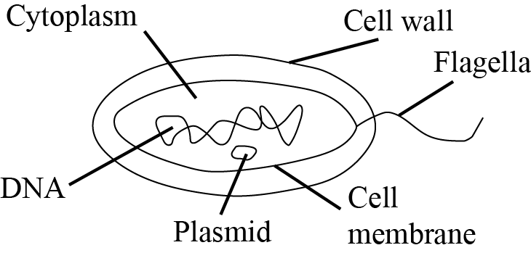  Virus Diagram  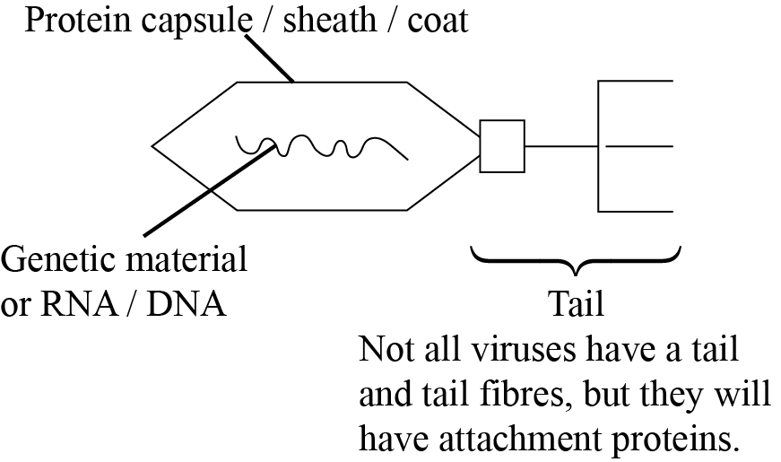

(b) | N0 – A4  - bacteria reproduce by binary fission /asexual reproduction/ (not mitosis)  - viruses replicate by the lytic cycle / viruses require a living host cell  - antibiotics kill bacteria (are bactericidal)  - antibiotics do not kill viruses  - antibiotics prevent the bacteria from building its cell wall OR disrupt its cell membrane./disrupt cell processes. | M5 – E8 Bacteria  - Binary fission is where one bacterial cell divides which forms two bacteria cells; this process continues until resources are limited  - Explanation of reproduction time: because this process takes about 20 minutes per division the colony will take time to build up.  The chromosome replicates and then moves to the opposite sides of the cell.  Replication finishes and the plasma membrane grows inwards and new cell wall is produced.  Two identical daughter cells are created.  Bacteria population  Time  Because of the time it takes for the bacteria to reproduce, there is a lag phase in the early growth of the bacterial population. As the population increases so does the toxic waste they produce, and as the numbers of the bacteria increase exponentially, so will the toxic wastes they produce. As the toxic waste increases, so do the symptoms shown by Angela.  - Explains that population increase is linked to increase in production of toxins.  - Explains that an increase in toxins is linked to an increase in the symptoms, therefore Angela would have felt the symptoms later than Manaaki due to the time it takes for the toxins to build up.
(b) | M5 – E8 Viruses  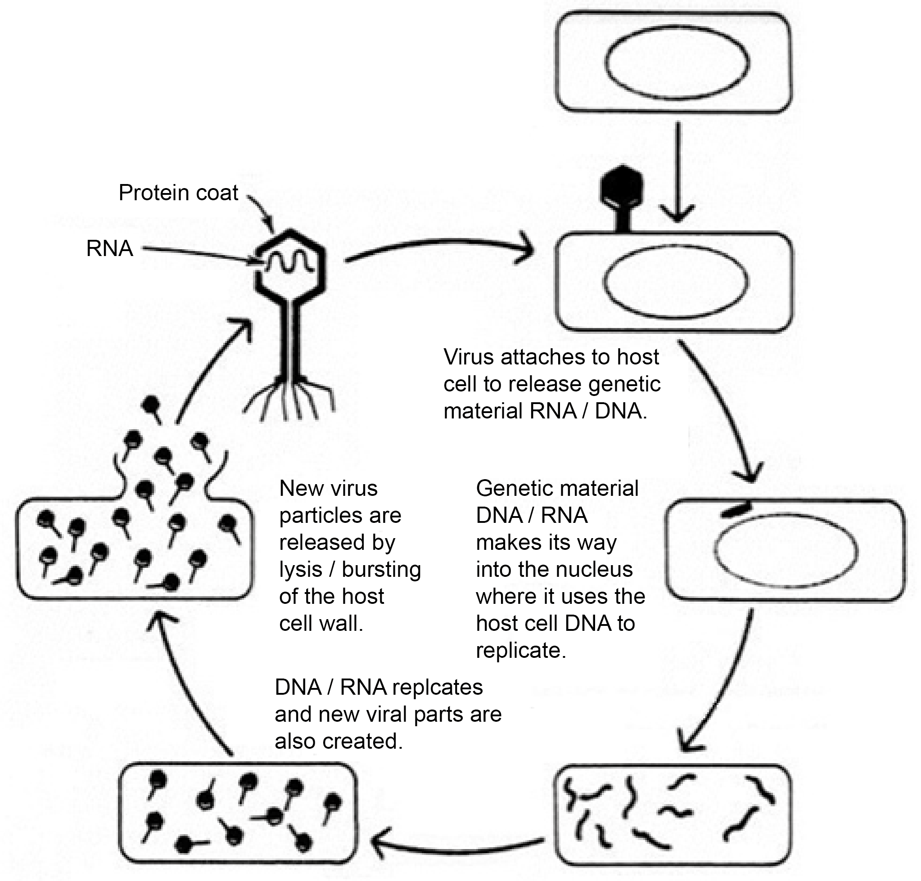  Adapted from http: / / goo.gl / fWnfFl  2/4 – correct:  attachment  insertion  replication  burst  - Because the infected cells release 100s of viruses when they burst, each individual virus is able to infect a different cell quickly, affecting many cells.  - Because this process takes only one cycle for the killing of many cells, the symptoms are felt really quickly because 100s of cells are killed.  How antibiotics affect life processes  - Antibiotics take advantage of the difference between the structure of the bacterial cell and the host’s cell.  - They either prevent the bacterial cells from multiplying so that the bacterial population remains the same, allowing the host’s defence mechanism to fight the infection; or they kill the bacteria, for example stopping the mechanism responsible for building their cell walls.  - Interfere with the bacterium’s ability to repair its damaged DNA.  OR  By preventing the bacterium from making what it needs to grow.  OR  By weakening the bacterium’s cell until it bursts.  Antibiotic resistance  - Some bacteria may gain a favourable mutation, which allows them to survive the action of the antibiotic.  - When an antibiotic is used, bacteria that can resist that antibiotic have a greater chance of survival than those that are “susceptible”. Susceptible bacteria are killed or inhibited by an antibiotic, resulting in a selective pressure for the survival of resistant strains of bacteria, which can reproduce by binary fusion.  Antibiotic resistance and how this would affect Angela’s symptoms  The bacteria that infected Angela might get a mutation, and they could be genetically different from each other. One or a few bacteria might be less susceptible to the antibiotic, and therefore are able to survive the first few days when Angela first took the antibiotics. The bacteria that were slightly resistant survived, and the bacteria that were not resistant died. This caused the symptoms to decrease and Angela felt better because the toxins that were produced by the bacteria which caused the symptoms, decreased as a result of the decrease in bacteria. Because Angela feels better, she does not complete the course of antibiotics, and the resistant bacteria then reproduce by binary fusion, causing an increase in resistant bacteria, and therefore an increase in toxins, making Angela feel the symptoms again. So she takes the antibiotics, but the bacteria do not die as they are now resistant to the antibiotic.

TWO | NØ | N1 | N2 | A3 | A4 | M5 | M6 | E7 | E8
TWO | No response / no relevant evidence. | ONE  idea given. | TWO  ideas given. | THREE  ideas given. | FOUR  ideas given. | Explains TWO of: | Explains THREE of: | Comprehensive explanation including that the yeast respires anaerobically when the conditions are good (40°C).  Optimal Temperature linked to growth  OR  Optimum temperature linked to respiration for enzyme action on the sugar substrate.  Linked to production of energy for reproduction of yeast / fungi (budding).  This is linked to a further increase in yeast and more carbon dioxide is produced. The rise in carbon dioxide is then linked to the rise in the bread dough.  Either seal OR refrigeration linked to a process. | Discussion MUST:  - relate the importance of the environment to the storage of yeast.  - Comprehensively explain that the yeast would activate if they came into contact with moisture / water, secreting enzymes.  Must link:  - the importance of lower temperatures to little or no energy available for reproduction.  - Lack of availability of sugar for respiration, so therefore no energy is available for reproduction.  Both seal AND refrigeration linked to a process.
TWO | N0 – A4  - The best temperature for respiration is 40°C.  - Anaerobic respiration does not require oxygen  - Yeast uses extra cellular digestion  - Cool conditions slows reproduction  Anaerobic cellular process that does not require oxygen to release energy from food molecules obtained by the fungi; this is called fermentation.  C₆H₁₂O₆ → 2C₂H₅OH + 2CO₂ + ATP (balancing not required)  OR Glucose → + ethanol + Carbon Dioxide + Energy  - Describes that the conditions for yeast to grow are, warmth, moisture and nutrients to survive. (Must have 2/ 3 conditions.) Suitable temperature / temperature by itself is not acceptable  - 40°C has the highest level of foam.  - Describes competition decreases with other microbes/pathogens  - Prevents contamination  Seal and Refrigeration linked to a process  How does temperature affect respiration energy. |  |  |  |  | - One must be extra-cellular digestion.  - links the height of the foam to respiration or the production of CO₂.  - ONE of any of the other explanations.  - Explains link to enzymes/ respiration. (low/high). | - One must be extra-cellular digestion. Must explain Large Molecule to small/ breaking down molecules  - One must link the height of the foam to respiration.  OR  - the production of CO₂.  - One of any of the other explanations.
TWO | Explanations required for M5 – E8  - Explains that fungi gain their food by extracellular digestion where they secrete digestive enzymes into the water / sugar / yeast solution, which breaks down large molecules like starch / sugar into glucose, and proteins into amino acids and fats into fatty acids. These smaller food molecules are absorbed / pass through the cell membrane.  (Because the water and sugar are given in the diagram, the candidates must give starch / large sugar being broken down to glucose to make it relevant to the question.)  - Explains that the 40°C had the highest level of foam because of the fungi releasing carbon dioxide caused by anaerobic respiration (must state correct temp).  - Explains that the higher the foam is, the more respiration has occurred and therefore more carbon dioxide is produced. This is because digestive enzymes work best at 40°C and break down the sugar into glucose to be used in anaerobic respiration.  - Explains that reproduction is also occurring, which increases the number of yeast cells by budding and producing more carbon dioxide because the optimal conditions are available, increasing the amount of respiration.  - Explains that yeast in a refrigerator is in cooler conditions, and this slows down any enzymes that could be secreted and therefore have little or no kinetic energy, and this means it cannot collide correctly with any substrate. Or that the enzyme might have a different shape, not allowing any collisions with the substrate.  - Explains that because the yeast is kept in a sealed airtight container there are no nutrients in the form of sugar solution for the yeast / fungi to use, so no anaerobic respiration takes place.  - Explains that yeast is kept in airtight conditions to prevent the yeast from respiring, as it does not have any moisture to use for anaerobic respiration.  - Explains that yeast is kept in the refrigerator to keep the temperature low, so respiration is low and therefore no reproduction occurs as there is no respiration to produce any energy for this process. |  |  |  |  |  |  | Must explain that the yeast respires anaerobically when the conditions are good (40°C).  This is because the enzymes act on the sugar substrate in the water breaking it into smaller glucose molecules, which are used in anaerobic respiration. This produces energy (ATP), required for reproduction of more yeast cells by budding. This also causes the production of carbon dioxide, which causes the bread dough to rise. The bread is then baked at high temperatures, causing the ethanol to evaporate.

THREE | NØ | N1 | N2 | A3 | A4 | M5 | M6 | E7 | E8
THREE | No response / no relevant evidence. | ONE idea given. | TWO ideas given. | THREE ideas given. | FOUR ideas given. | Explains One of:  - the importance of turning over the compost.  (Provides more oxygen for respiration.)  - how turning over the compost increases the temperature, increasing respiration.  - the importance of bacteria being able to fix nitrogen or produce carbon for plant growth. | Explains Two of:  - the importance of turning over the compost.  (Provides more oxygen for respiration.)  - s how turning over the compost increases the temperature.  (Increases respiration.)  - the importance of bacteria being able to fix nitrogen or produce carbon for plant growth. | Comprehensively explains Three of:  - the importance of bacteria and fungi as decomposers to the carbon cycle.  - The nitrogen cycle.  - the importance of increasing the temperature of the compost heap.Kills the pathogens and seeds and allows thermophiles to break down nutrient-rich plant material. | Comprehensively explains  - the importance of bacteria and fungi as decomposers to the carbon cycle.  - Respiration of fungi and bacteria, relating the importance of CO₂ for photosynthesis, producing glucose, a carbon compound  - The nitrogen cycle  - Plants use nitrates which are important for making proteins required for plant growth  AND  Breaks down insoluble forms of nitrogen to soluble form called nitrate that can be used for plant growth  OR  - Comprehensively explains the importance of increasing the temperature of the compost heap.  (Kills the pathogens and seeds and allows thermophiles to break down nutrient-rich plant material.)
(a) The diagram should show:
- Nitrate being used by plants and then eaten by animals (nitrate is a useable form of nitrogen in plants).
- Nitrogen-fixing bacteria converting atmospheric nitrogen into nitrates to be used in plants to build amino acids.
- Can also convert atmospheric nitrogen into ammonia and urea.
- Nitrifying bacteria can convert ammonia and urea into nitrites.
- Nitrifying bacteria converts nitrites into plant materials.
- Animals get their nitrogen by eating plant materials.
- Aerobic respiration is more efficient than anaerobic respiration.
- Anaerobic respiration/ uses oxygen
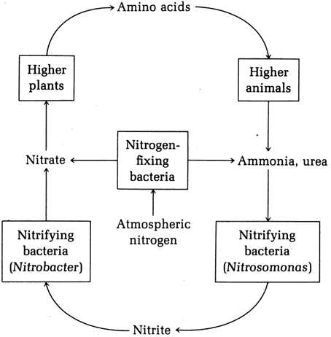
- Diagram may show the direction of nitrogen being changed into different forms of nitrogen –ie from atmosphere to soil etc

 | (b)  - The type of bacteria involved in breaking down the organic carbon molecules is a decomposer / saprophyte  - Turning over the compost heap allows more oxygen for the microbes’ aerobic respiration.  - Turning over the compost increases the temperature of the compost  - Any correct statement which identifies a trend linked to the graph  - The temperature increases as the respiration of the microbes increases  - This allows for thermophilic respiration. For the first 20 days, the temperature of the microbes increased as the population of saprophytes increased.  - Carbon dioxide is released into the environment by decomposers / bacteria and fungi respiring in the compost heap  - Respiration of the saprophytes and decomposers is  C₆H₁₂O₆ +6O₂ → 6CO₂ + 6H₂O + ATP (balancing not required)  glucose + oxygen → carbon dioxide + water + energy |  |  |  |  | (a)  The statements need to be linked  - By turning over the compost every three days, respiration of the microbes increases, as does the temperature of the compost heap.  - The compost heap that is turned over every 3 days had a larger rise between 0 and 20 days and decline in their temperature from 20 to 40 days.  - Between 10 and 30 days the temperature allows some decomposers to die and they are replaced by other decomposers, which survive the hotter conditions, called thermophiles.  - When the compost is turned over every 10 days, temperature rises less, as there is less available oxygen for respiration.  - Because the temperature does not get as high between 0 and 20 days, the recycling of nutrients is slower because the thermophilic bacteria cannot live and reproduce at this temperature.  - If the compost heap was turned over every 30 days, then it would be not get as hot as when turning it over more frequently.  - The high temperature in a compost heap also kills pathogenic microbes and weed seeds. |  | (b)  - A compost heap has an insulated centre which provides the best conditions for enzymes to work.  - Thermophilic microbes start to work as they are able to digest the high energy material such as fat and protein molecules which cooler temperature microbes struggle with.  - Once the high-energy-rich molecules are used up, the temperature of the compost falls, and the lower temperature microbes take over.  - The decomposers break down the material to ammonium that can be acted on by denitrifying bacteria and nitrifying bacteria. The nitrifying bacteria convert ammonium to nitrates, which can be used by plants to build proteins. The denitrifying bacteria convert the ammonium into atmospheric nitrogen.  - (Decomposers) bacteria and fungi respire anaerobically and release carbon dioxide into the atmosphere for plants to use in photosynthesis.

Cut Scores
Not Achieved | Achievement | Achievement with Merit | Achievement with Excellence
0 – 6 | 7 – 13 | 14 – 18 | 19 – 24

